Step1. Prepare the two brass conductor parts.
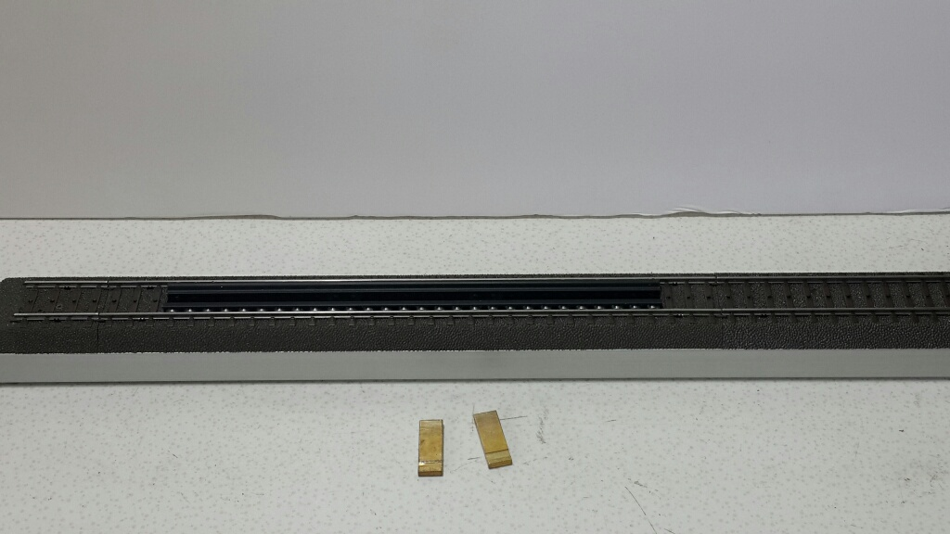

Step2. Take the brass conductor parts then insert into the hole (the ditch near the bottom)
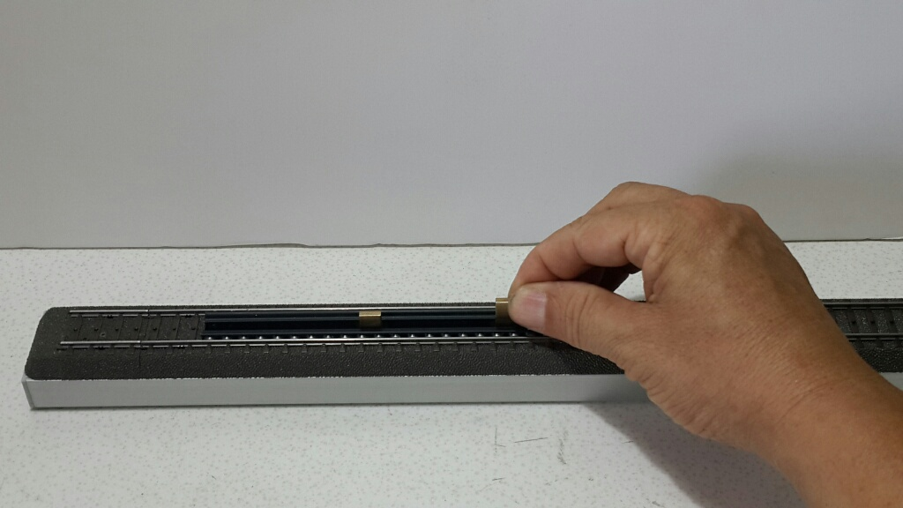
‘

Step3. Use the hammer to knock the brass conductor parts into the bearing set.
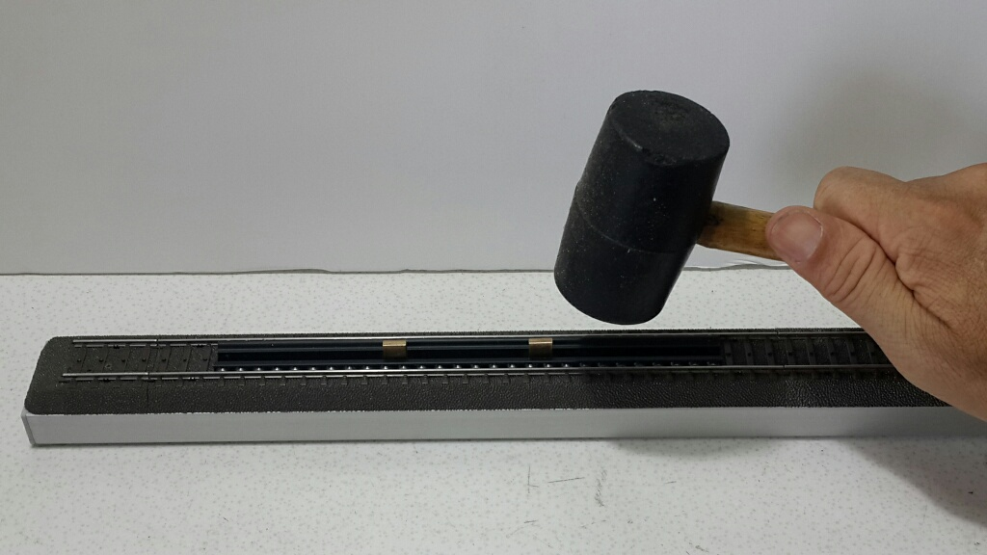
PS: If you are not a Marklin 3 tracks fans you don’t need to install the “brass conductor parts”.

